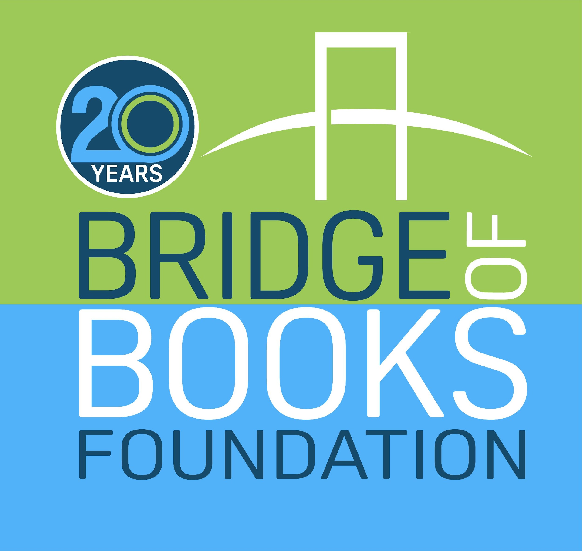

**Books for Birthdays!**

**Please help (*b’day child’s name*) share the joys of a good book.**

**Instead of bringing a gift, please bring a new children’s book for**

**The Bridge of Books Foundation.**

**Bridge of Books is a 501(c)(3) organization that donates new and gently used books to underserved children throughout New Jersey.**

***To learn more about Bridge of Books, please visit*** [***www.bridgeofbooksfoundation.org***](http://www.bridgeofbooksfoundation.org)

***________________________________________________________________***



***Books for Birthdays!***

**Please help (*b’day child’s name*) share the joys of a good book.**

**Instead of bringing a gift, please bring a children’s book for**

**The Bridge of Books Foundation.**

**Bridge of Books is a 501(c)(3) organization that donates new and gently used books to underserved children throughout New Jersey.**

***To learn more about Bridge of Books, please visit*** [***www.bridgeofbooksfoundation.org***](http://www.bridgeofbooksfoundation.org)