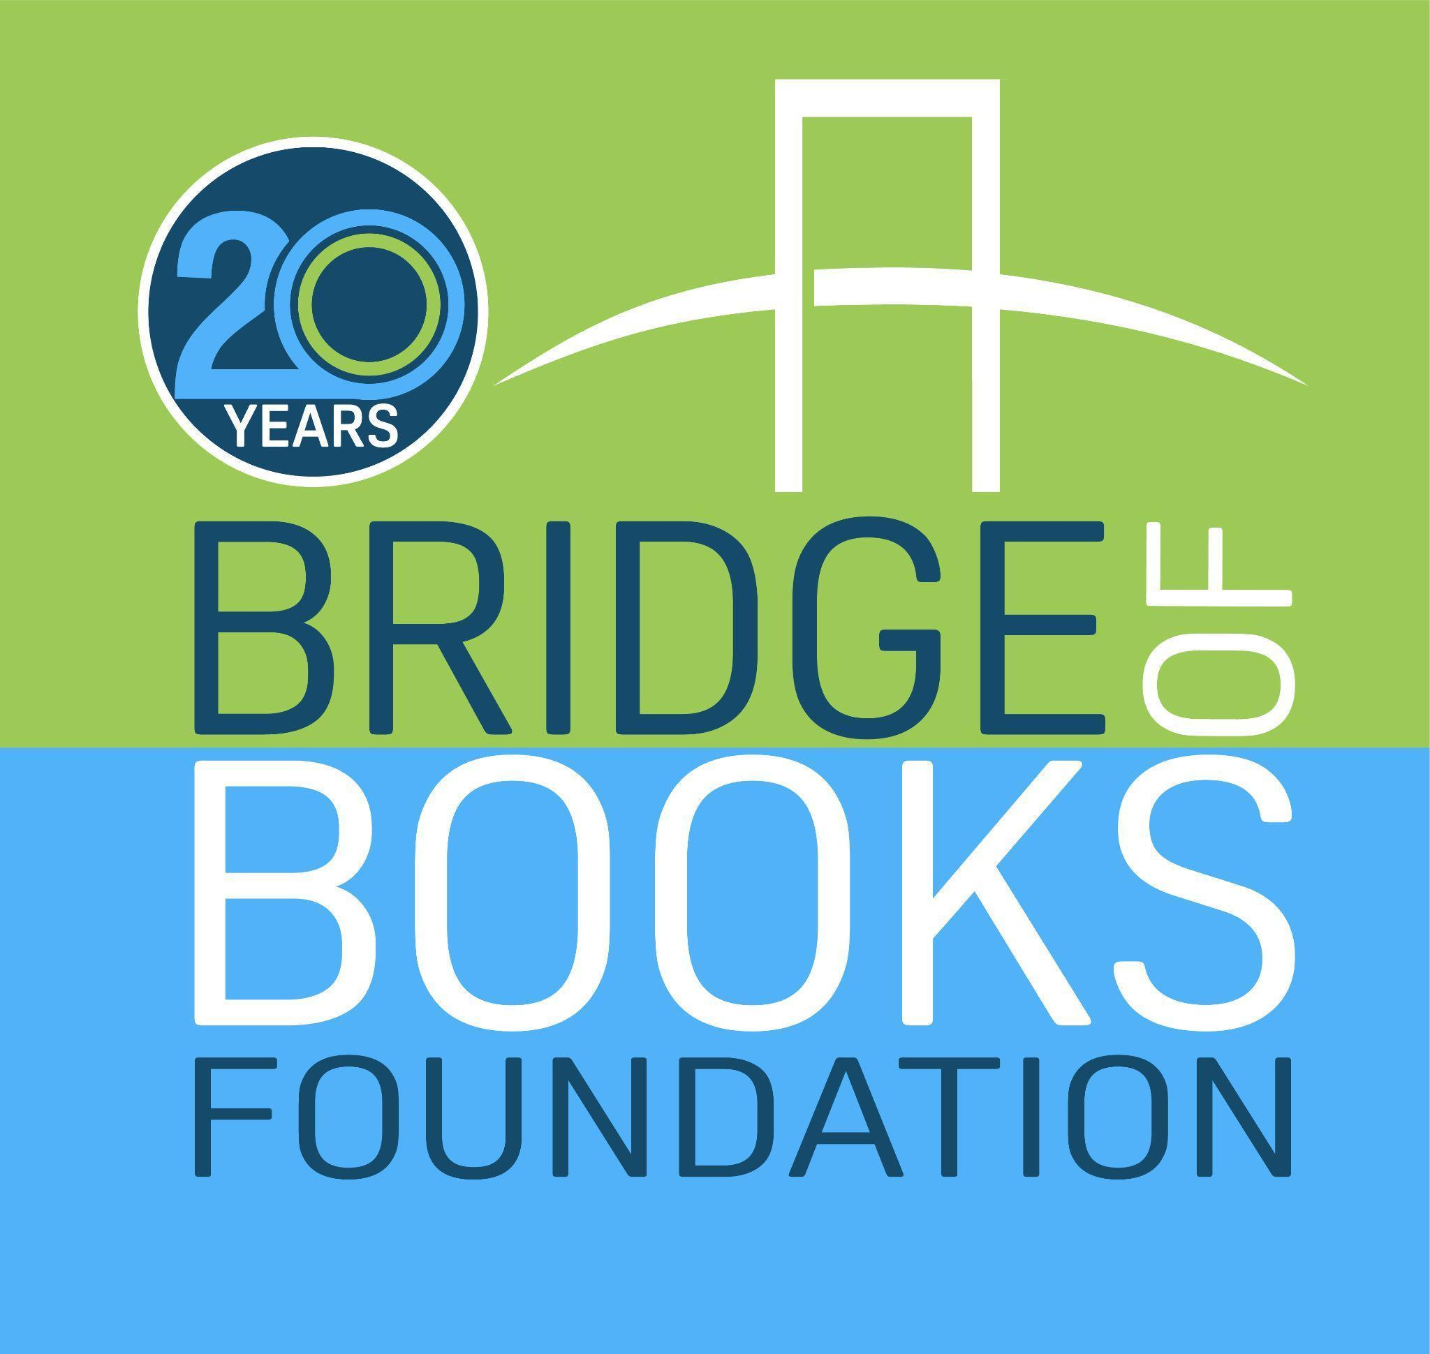

# (Sample email for book drive to benefit *The Bridge of Books Foundation*. Feel free to send as an attachment or copy, edit, and send as appropriate to your audience!)

**CHILDREN’S BOOK DRIVE!**

______________________ is hosting a book drive for The Bridge of Books Foundation. Operating as a 501(c)(3), Bridge of Books’ mission is to provide an ongoing source of new and gently used books to underserved kids throughout New Jersey to support the development of literacy efforts and encourage a love of reading.

We are looking to collect:

* New and gently used books for kids from birth through age eighteen
* If a book makes sounds, it must work
* If a book has parts, it must have **all** of its parts
* If a book has stickers, it must have **all** of the stickers

We are **not** looking to collect:

* Adult books, textbooks, encyclopedias, coloring books, used work books or magazines
* Books that are old, yellowed and/or missing pages
* Discarded books from libraries, including teacher classroom libraries
* **One exception – Bridge of Books will accept parenting books!**

A collection (binl/box) will be placed at ___________ from _______________ to ________________.

Should you have any questions, please contact _____________.

To learn more about The Bridge of Books Foundation, please visit [www.bridgeofbooksfoundation.org](http://www.bridgeofbooksfoundation.org)

Thank you for giving the gift of literacy!